
Detailed Solution Design for TON x Ignyte Global Challenge: Web3 Payments on Telegram
This comprehensive solution design addresses the TON x Ignyte Global Challenge's mission to accelerate Web3 payment adoption within Telegram by building plug-and-play solutions for businesses, payments, and tokenization. The solution encompasses three interconnected use cases: bill splitting among friends, merchant payment acceptance with loyalty tokenization, and frictionless tipping for service workers.
Executive Summary and Key Findings
The proposed solution integrates non-custodial wallet technology, smart contract-based loyalty programs, and real-time settlement mechanisms to transform everyday transactions into blockchain-enabled experiences seamlessly embedded within Telegram. By leveraging TON's high-throughput architecture (millions of transactions per second) and minimal transaction fees, the platform enables mass-market adoption while maintaining enterprise-grade security and compliance. The solution is architected as a multi-tenant SaaS platform with modular microservices, allowing independent merchants and service providers to activate within minutes. Three complementary mini-apps—Bill Splitter, Merchant Payment Hub, and Service Worker Tipping Platform—create a cohesive ecosystem where loyalty tokens represent real ownership and can be redeemed across participating partners.^{[1][2][3][4][5][6]}
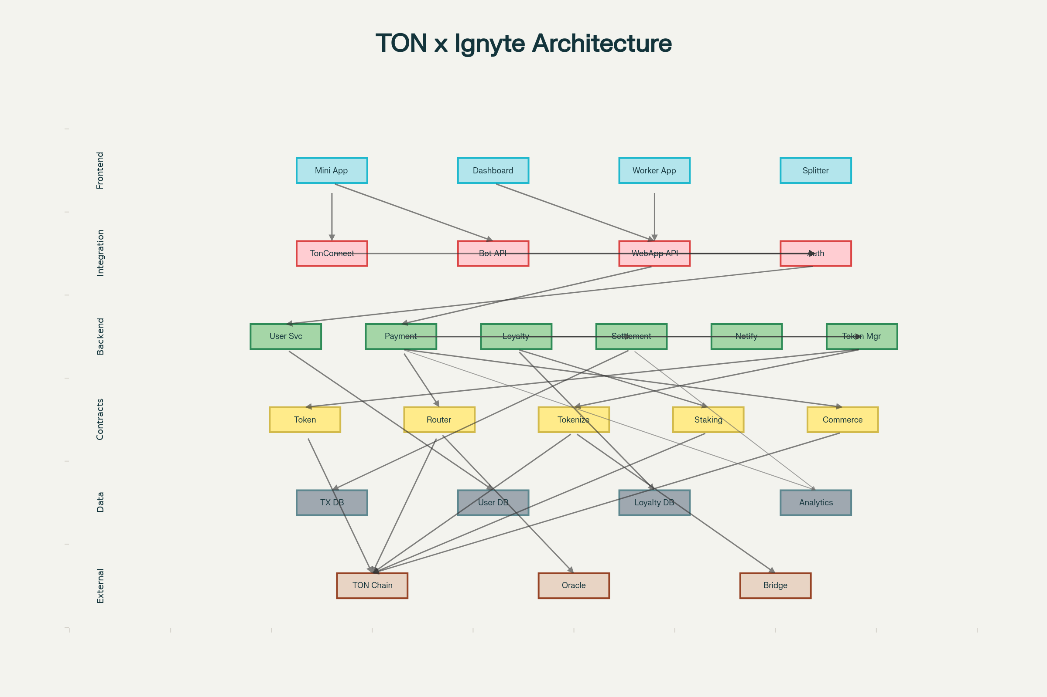
TON x Ignyte Web3 Payment Platform - System Architecture Overview
Core Architecture and Technical Foundation
System Design Overview
The solution employs a layered microservices architecture optimized for Telegram's mini app environment, combining React-based frontends with a Node.js/TypeScript backend, TON smart contracts, and PostgreSQL/MongoDB data persistence. The frontend integrates the TonConnect wallet SDK to enable non-custodial asset management, eliminating the need for users to create new accounts or manage separate cryptocurrency wallets. All payment processing flows through the Telegram Stars payment system for fiat-to-crypto conversions, with atomic settlement on TON's Layer 1 blockchain within seconds.^{[7][8][9][10]}
The backend implements a service-oriented architecture with clear separation of concerns: the Authentication Service handles TonConnect integration and user identity verification; the Payment Engine processes transactions and routes them to appropriate settlement pathways; the Loyalty Program Engine manages token minting, redemption, and staking mechanics; the Settlement Service ensures immutable on-chain recording; and the Notification Service delivers real-time updates via WebSocket connections and push notifications. Each service exposes RESTful APIs and WebSocket endpoints for real-time data synchronization, with message queuing (Redis/RabbitMQ) for asynchronous event processing to handle traffic spikes during peak shopping hours.^{[11][12][13]}
Smart Contract Ecosystem
The solution deploys six interconnected smart contracts on TON, each addressing specific functional requirements:
1. Loyalty Token Contract (TIP-20 Standard): Implements the OpenZeppelin ERC-20 pattern adapted for TON, defining the core loyalty token issued to users for purchases, referrals, and rewards. State variables track total supply, user balances, allowances, and metadata. The contract enforces role-based access control, permitting only the Token Manager Service and authorized merchants to mint new tokens. Burn functions enable redemption pathways where customers convert accumulated loyalty points into redeemable value.^{[14][15]}
2. Payment Router Contract: Routes incoming TON payments to appropriate handlers based on transaction metadata. When a user sends TON, the contract identifies whether the transaction represents a direct payment, bill split settlement, or tip, then delegates to the corresponding handler contract. The router maintains a registry of active merchant addresses and their settlement wallets, enabling dynamic routing without contract redeployment.^{[16]}
3. Tokenization Engine Contract: Transforms physical or digital assets into blockchain-backed tokens representing ownership or claims. For mall loyalty programs, this contract enables merchants to issue redeemable tokens backed by real rewards (discounts, exclusive access, merchandise). For airline partnerships, it tokenizes frequent flyer miles into tradeable tokens usable across merchant ecosystems. The contract implements staking functionality, allowing users to lock loyalty tokens to earn yield or unlock premium tiers.^{[3][4][17]}
4. Staking and Rewards Contract: Manages yield generation for locked loyalty tokens using a Proof-of-Stake model. Users can delegate loyalty tokens to earn rewards, with compounding calculated per epoch. The contract tracks staking commitments, slashing penalties for early withdrawal, and distributes rewards from protocol reserves or merchant incentive pools. This creates continuous engagement and passive income generation for loyal customers.^{[17][3]}
5. Merchant Registry Contract: Maintains an on-chain registry of authenticated merchants, their operational parameters (loyalty point distribution rates, reward tiers, tokenization rules), and settlement preferences. Enables merchants to update parameters autonomously, execute emergency pauses, and configure multi-signature requirements for fund movement.^{[11]}
6. Multi-Signature Wallet Contract: Protects high-value operations and fund movements by requiring approval from N-of-M designated signatories (e.g., 2-of-3 founders, 1-of-2 auditors). Time-locks critical functions to allow challenge periods, implementing circuit-breaker patterns for emergency fund recovery.^{[11]}
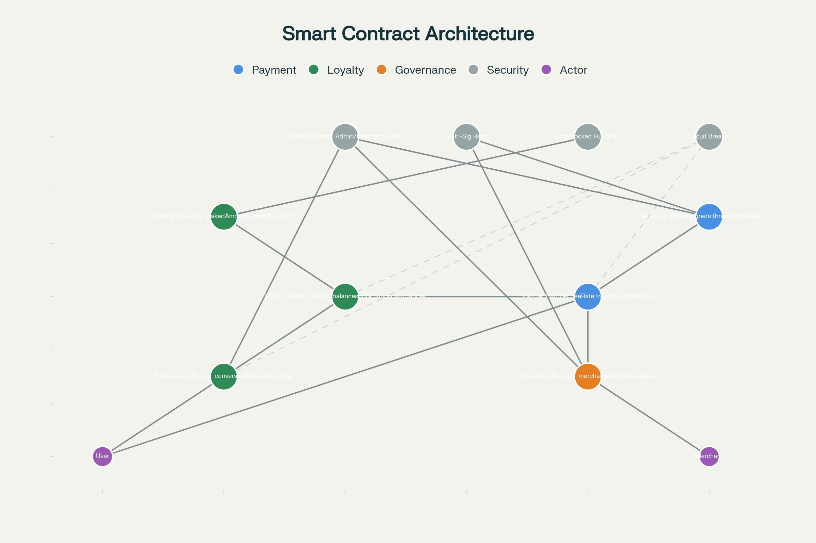
Smart Contract Architecture and Interaction Patterns
Detailed Solution Components by Use Case
Use Case 1: Bill Splitting Among Friends
Problem Statement: Traditional bill splitting requires multiple intermediaries, currency conversions, and delayed settlements. The proposed solution enables instant, frictionless settlement directly within Telegram.
Technical Implementation: The Bill Splitter Mini App (React-based) integrates directly into Telegram as a Web App, accessible via inline buttons or dedicated bot commands. Users authenticate using TonConnect, connecting their non-custodial wallet without creating new credentials. When initiating a split, users select participants from their Telegram contacts, input expenses with categories, and authorize the app to calculate optimal settlement pathways—ensuring minimum number of transactions needed to balance all debts.^{[7][9][12]}
The app uses a graph-based algorithm to determine the most efficient settlement sequence. For example, in a three-person scenario where Alice owes Bob $10, Bob owes Charlie $5, and Charlie owes Alice $2, the algorithm calculates that Alice should pay Bob $8 and Bob should pay Charlie $5, resulting in only two transactions instead of three.^{[12]}
Payment execution leverages Telegram Stars for instant fiat-to-TON conversion at market rates, then initiates atomic transfers via the Payment Router Contract. Each transaction generates an on-chain record with cryptographic proof, enabling dispute resolution if needed. Settlement completes within seconds, with WebSocket notifications confirming delivery to all participants.^{[13]}
The Notification Service sends push alerts to each participant confirming their balance changes, with deep links back to the app for dispute filing or balance review. Persistent settlement records stored in PostgreSQL enable historical analysis, spend categorization, and budgeting recommendations powered by ML-based expense insights.
Revenue Model: Capture 1-2% platform fee on settled amounts, with premium tier offering budget forecasting, recurring expense automation, and group analytics. Merchant partnerships enable promotional discounts for spending within integrated retailers.
Use Case 2: Merchant Payment Acceptance and Loyalty Tokenization
Problem Statement: Small merchants in Dubai malls, cafés, and service businesses lack affordable, frictionless payment infrastructure. Traditional POS systems bundle expensive hardware, high transaction fees, and complex integration. The challenge specifically addresses malls, airlines, cafés, and small shops needing plug-and-play solutions that accept crypto, reward customers, and run loyalty programs.^{[18][19]}
Technical Implementation: The Merchant Payment Hub provides three tiers of integration:
Tier 1 - Minimal Integration (QR Code Payments): Merchants receive a custom QR code embedding their TON wallet address and merchant ID. Customers scan the code using the Telegram Mini App's integrated scanner, review the transaction, and authorize payment with one tap. No additional hardware required; works on any smartphone with Telegram installed. Transactions settle on-chain within seconds, with funds deposited directly to the merchant's wallet.^{[20]}
Tier 2 - NFC Integration: Merchants deploy NFC terminals (cheap, passive hardware costing ~$20-50) for tap-to-pay functionality. Users tap their NFC-enabled phones, and the integrated payment app processes the transaction. Enables faster checkout in high-throughput environments like cafés during peak hours. Includes inventory sync, automatic receipt generation, and customer data capture.^{[21]}
Tier 3 - POS System Integration: For larger merchants (airlines, major malls), the solution provides API hooks to existing ERP/CRM systems, enabling seamless inventory updates, real-time loyalty point calculation, and automated reporting. The API accepts transaction data in standardized formats and returns settlement confirmation with merchant-specific receipts.^{[7][18]}
Loyalty Tokenization Engine: When a customer completes a purchase, the app automatically mints loyalty tokens proportional to transaction value. For example, a $100 purchase yields 100 LoyaltyTokens (1:1 ratio configurable per merchant). These tokens are transferred to the customer's connected wallet, visible in their balance dashboard.
Merchants configure tiered loyalty structures:
- Bronze Tier: 1 loyalty point per dollar spent, no additional benefits
- Silver Tier: 1.5 points per dollar, 5% discount on redemptions
- Gold Tier: 2 points per dollar, early access to new products, VIP customer support
- Platinum Tier: 3 points per dollar, exclusive events, personal shopper access
Each tier has automatic unlock criteria (e.g., $500 lifetime spending), and customers can check tier status within the app. Loyalty tokens never expire; merchants cannot unilaterally reduce their value or change redemption terms, ensuring customer ownership and trust.^{[3][4]}
Cross-Merchant Ecosystem: The solution enables loyalty token interoperability across mall tenants. Customers earn tokens from individual stores but can also redeem them at mall-wide events, participate in mall-wide promotions, or convert them to a common "Mall Token" for broader utility. This network effect increases merchant participation incentives while enhancing customer lifetime value.^{[4][3]}
Merchant Dashboard: Web-based portal (built with React and Node.js backend) provides real-time analytics: daily revenue, top customers, loyalty token distribution metrics, inventory levels, and staffing costs. Merchants set custom business rules (e.g., "double loyalty points on Fridays"), monitor tier distribution, and create targeted campaigns ("Buy 2, Get 50% loyalty points back"). Enables data-driven decisions without requiring advanced analytics expertise.^{[19][18]}
Compliance and Security: All payment transactions leverage Telegram Stars for regulated fiat processing, ensuring compliance with UAE financial regulations. The system implements Know-Your-Customer (KYC) verification for merchants exceeding transaction thresholds and automated Anti-Money-Laundering (AML) checks. Smart contracts include circuit-breaker patterns to halt suspicious activity instantly.^{[11]}
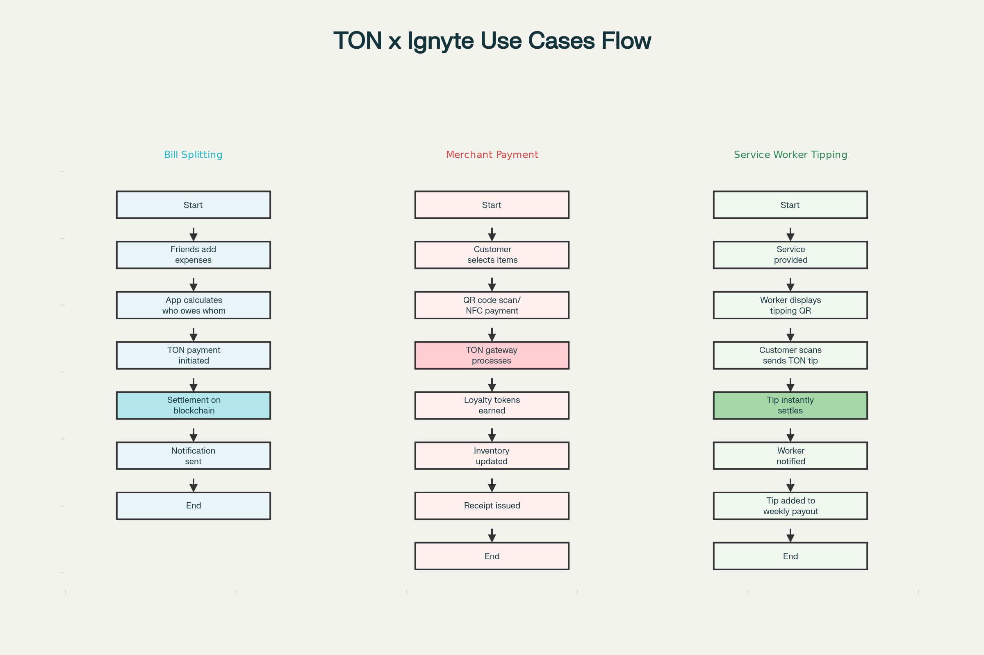
Three Core Use Cases - User Journey and Transaction Flows
Use Case 3: Frictionless Tipping for Service Workers
Problem Statement: Service workers (waiters, hairdressers, drivers, hotel staff) in Dubai often receive cash tips, creating accounting headaches, security risks, and tax reporting complexity. Crypto-based tipping enables instant settlement with cryptographic proof, eliminating intermediaries and enabling gig worker empowerment.^{[22][21]}
Technical Implementation: Service Worker Tipping Platform (separate Telegram Mini App) enables:
Customer-Initiated Tipping: After service completion, customers scan the service worker's personal QR code or tap their NFC badge. The app displays tip suggestions (10%, 15%, 20% of bill) or enables custom amounts. Customers authorize a TON transfer with one tap; the transaction settles immediately to the worker's wallet.^{[21]}
Direct Settlement Without Intermediaries: Unlike traditional tipping apps that batch payments weekly or charge processing fees, TON-based tipping settles instantly. Workers see confirmed balance updates in real-time, with full ownership of received funds. No central intermediary controls or freezes funds; workers maintain non-custodial control via TonConnect.^{[22]}
Weekly Payout Automation: Workers can configure automatic weekly payouts to traditional bank accounts via USDT-to-fiat bridges (integrated partnerships with regulated exchange partners). Alternatively, they can maintain balances in TON/USDT for crypto-native operations. The system generates tax-compliant reports (itemized by date, customer, amount, category), simplifying income reporting.^{[22]}
Loyalty Token Rewards: Service workers earn additional loyalty tokens for high-rated performance. Customers rate service quality (1-5 stars) after tipping; excellent ratings (4-5 stars) trigger 10% bonus tokens to workers' loyalty balances. Workers can redeem these tokens at participating merchants, creating an incentive flywheel improving service quality.^{[3]}
Performance Analytics Dashboard: Workers access real-time dashboards showing daily/weekly/monthly earnings, average tip percentages, customer ratings distribution, and peer benchmarks (top earners in their venue). Gamified leaderboards (no financial ranking, only recognition) encourage healthy competition and motivate service excellence.^{[21]}
Multi-Location Support: Hospitality managers coordinate tipping across multiple locations, track staff performance centrally, and allocate performance bonuses. The system handles payroll integration, ensuring tips are separated from salary and taxed appropriately per jurisdiction.^{[21]}
Data Architecture and Persistence
The solution implements a hybrid data model combining blockchain immutability with relational database performance:
PostgreSQL (Primary Data Store): Stores user profiles (Telegram ID, TON address, preferences), merchant configurations, loyalty tier assignments, transaction metadata (amounts, timestamps, categories), and customer ratings. Enables fast queries for dashboards and analytics without blockchain read costs. Implements row-level security so users can only access their own data.^{[17]}
MongoDB (Analytics and Audit Trail): Stores unstructured data including customer transaction history, merchant activity logs, and system events for compliance audits. Enables time-series analysis (trending products, seasonal spending patterns) without impacting transactional database performance.^{[17]}
TON Blockchain (Immutable Settlement): Definitive record of all financial transactions, loyalty token movements, and settlement confirmations. Enables dispute resolution with cryptographic proof and enables users to verify their balances independently without relying on centralized systems.^{[1][5]}
Redis (Cache and Sessions): Caches frequently-accessed data (merchant loyalty point rates, user tier status, current exchange rates) to reduce database queries and improve API response times. Manages WebSocket connection state for real-time notifications.^{[13]}
Security and Compliance Framework
Authentication & Authorization: TonConnect integration provides non-custodial authentication using wallet signatures, eliminating password management overhead. Supports multi-signature wallets for merchant accounts, requiring N-of-M merchant stakeholders to approve high-value transactions.^{[10]}
Encryption: All user data encrypted at rest using AES-256 and in transit using TLS 1.3. Payment request payloads double-encrypted with merchant-specific keys to prevent man-in-the-middle attacks.^{[16][20]}
Smart Contract Auditing: All contracts undergo third-party security audits before mainnet deployment. Runtime monitoring detects anomalous transaction patterns (e.g., sudden liquidity drain attempts) and triggers circuit-breaker pauses.^{[11]}
Compliance: KYC/AML integration with regulated service providers ensures regulatory compliance with UAE FinTech guidelines. Transaction limits and daily spend caps configurable per jurisdiction. Automated suspicious activity reporting to financial authorities where required.^{[16]}
Deployment and Scaling Strategy
Phased Rollout:
- Phase 1 (Weeks 1-4): Deploy Bill Splitter mini app and merchant payment QR code infrastructure at 10 partner merchants in Dubai
- Phase 2 (Weeks 5-8): Expand to 50 merchants, add NFC integration, launch loyalty tokenization
- Phase 3 (Weeks 9-12): Onboard service worker tipping, integrate with 100+ merchants, launch cross-merchant redemption
- Phase 4 (Post-Challenge): Scale to regional partnerships, airline integrations, international expansion^{[18][19]}
Infrastructure: Deploy on AWS using containerized microservices (Docker/Kubernetes). Backend services scaled horizontally to handle thousands of concurrent connections. Database replication across regions for disaster recovery. CDN for static assets ensuring sub-200ms response times globally.^{[17][9]}
Go-to-Market: Partner with UAE retail associations and Dubai Chamber of Commerce for merchant recruitment. Leverage Telegram's 950M user base with organic growth through referral incentives. Create influencer partnerships (popular Dubai content creators) demonstrating tipping/loyalty features in daily scenarios.
Competitive Differentiation and Revenue Opportunities
vs. Traditional Payment Networks: Eliminates interchange fees (typically 2-3%), enabling merchants to pass savings to customers through enhanced loyalty programs. Instant settlement removes working capital delays. Non-custodial architecture eliminates regulatory burden of holding customer funds.^{[16]}
vs. Existing Crypto Payment Solutions: Fully embedded in Telegram (no app downloads), supporting 950M existing users. Superior UX with one-tap checkout (TonConnect pre-authentication). TON blockchain's throughput handles mainstream adoption without congestion (vs. Ethereum's $50+ fees during peak usage).^{[1][5]}
Revenue Streams:
- Platform transaction fees (0.5-1% for B2B SaaS merchants)
- Premium tier subscriptions ($99-499/month for advanced analytics, API access)
- Loyalty token staking/yield distribution (take 10-15% commission on generated yields)
- Cross-merchant ecosystem fees when tokens redeemed across brands
- Data analytics licensing to mall operators and retail conglomerates
- Integration fees for ERP/CRM system connections^{[18][19][16]}
This comprehensive solution directly addresses the TON x Ignyte Challenge's mandate to reimagine Web3 as a natural part of everyday life within Telegram, making cryptocurrency adoption accessible to mainstream users through familiar use cases and seamless mobile experiences.^{[23][24][25]}
⁂

- https://blog.ton.org/ton-telegram-web3-adoption
- https://www.linkedin.com/posts/ignyte-ae_ton-challenge-activity-7389602968624377856-psVz
- https://www.coinmetro.com/learning-lab/crypto-loyalty-programs
- https://www.blockchainappfactory.com/blog/case-studies-in-token-success-how-brands-are-transforming-customer-loyalty/
- https://www.linkedin.com/pulse/ton-blockchain-real-world-use-cases-success-stories-sainath-survase-okbpf
- https://www.cisin.com/coffee-break/airlines-uses-azure-to-convert-customer-s-air-miles-into-blockchain.html
- https://bazucompany.com/blog/integrating-payment-systems-into-telegram-mini-apps-a-comprehensive-guide/
- https://dev.to/leen2233/how-to-integrate-telegram-payments-in-a-django-and-react-mini-app-4cnn
- https://hostman.com/tutorials/how-to-create-a-telegram-mini-app-with-react/
- https://bybit-web3.github.io/ton
- https://www.rishabhsoft.com/blog/how-to-build-a-multi-tenant-saas-application
- https://www.sevensquaretech.com/behind-the-split-bill-splitting-app/
- https://xrpl.org/docs/tutorials/http-websocket-apis/build-apps/monitor-incoming-payments-with-websocket
- https://www.quicknode.com/guides/ethereum-development/smart-contracts/how-to-create-and-deploy-an-erc20-token
- https://www.calibraint.com/blog/erc20-smart-contracts
- https://tokenminds.co/content/web3-payment-gateway
- https://blockchain.oodles.io/defi-staking/
- https://campaignme.com/stores-screens-and-more-reinventing-retail-loyalty-in-the-uaes-phygital-era/
- https://persianhorizon.com/podcast/dubais-smart-retail-revolution-how-technology-is-transforming-shopping-experiences/
- https://core.telegram.org/bots/webapps
- https://tipmee.app/blog/digital-tipping-platforms-hospitality-service/
- https://defiway.com/blog/crypto-untapped-power-micropayments-and-tipping-revolution
- https://app.ignyte.ae/public/challenges/5BA38D91-2EA4-F011-8E61-002248CB55C0
- https://app.ignyte.ae/public/challenges
- https://www.linkedin.com/posts/mohammad-alblooshi-2499b54a_ignyte-launches-its-latest-web3-challenge-activity-7381684278281023488-GqEN
- https://x.com/ton_blockchain/status/1975910586564145298
- https://www.calypso.finance/coins-tokens/ton-payments
- https://www.youtube.com/watch?v=VeI7vciMJAU
- https://www.instagram.com/reel/DQvsf8CD23B/
- https://www.icsc.com/uploads/default/Omnichannel_and_Digital_Transformation_Part_I.pdf
- https://qwizeen.io/feature/inventory
- https://www.instagram.com/p/DPjJPWyjNzC/
- https://blog.bitunix.com/en/cross-chain-liquidity-pools-explained/
- https://nintyzeros.substack.com/p/splitwise-system-design-hld

